Project Proposal

Date: 08/10/2019  
   
Dear Rogério,  
   
Thank you for your response, we have reviewed our idea and have decided to go a new route. We have added answers to the key questions below:  
   
**What do we intend to do?**  
   
We wish to create a website to simulate a trading environment aimed mostly at students. It will aim to train by providing historical scenarios where users can invest artificial money into currencies and visualise how these investments will play out over the course of days, weeks, months or years.   
   
Our website will allow users to craft strategies and build confidence in their trading abilities, allowing them to gain a strong trading knowledge before entering the real world.  
   
 For example:

Take a student with no trading experience, they open a free account on our website and begin a trading scenario. They pick Bitcoin as the currency and the date starting December 2017. The simulation will display the graph up until that time in a specified time range and allow them to invest whatever amount of artificial currency they wish. Once they are happy, they can fast forward in time a number of hours, days, weeks or months and review their investment, making changes as they go to maximise profits and reduce losses.

**Initial UI Design:**  
 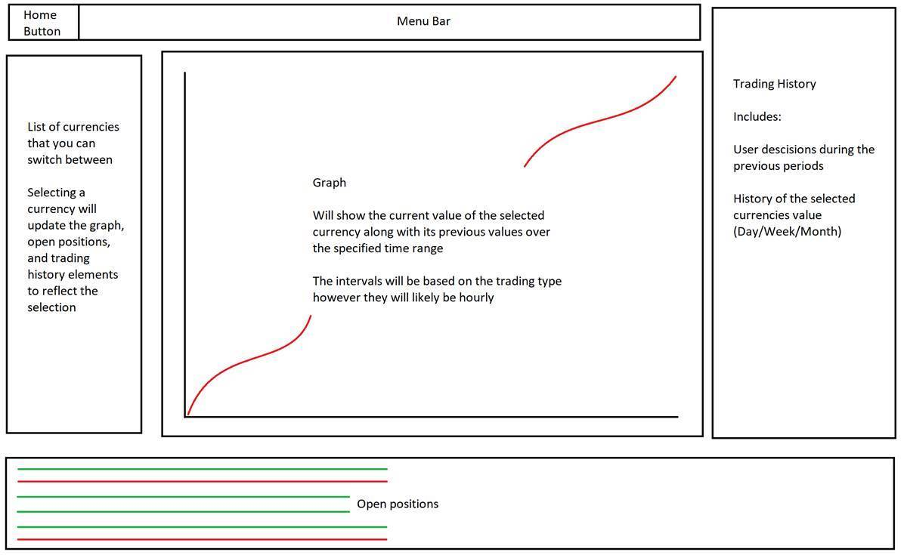

* + A menu bar containing:
    - Account options
      * Login/Logout
    - Trading Scenario options
      * Restart
      * Load
      * Save
    - Quick links to:
      * Live pricings
      * Help page
  + A have graph displaying the data.
  + A list of open positions.
  + A history of the users trading history.
  + A history of the currency’s value over the previous days.

**Use Case Diagram:**  
   
 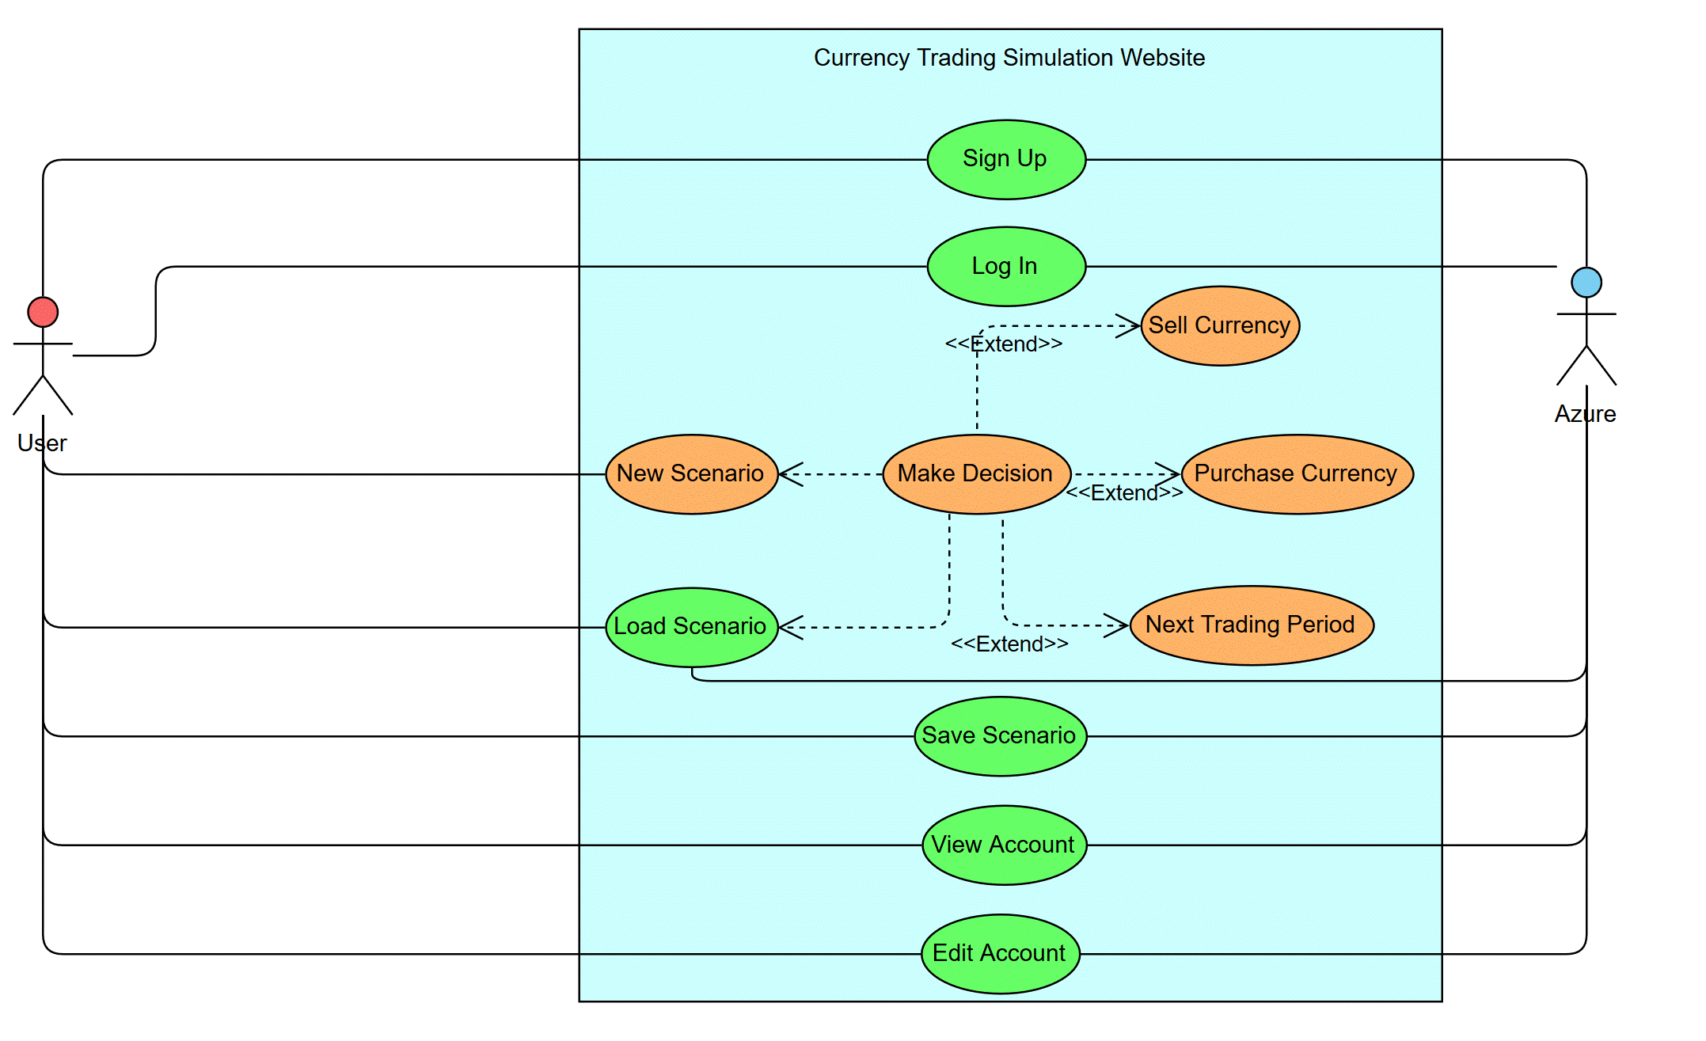

**Why?**  
   
The website will help to share knowledge on how currency trading works to aide in preventing individuals from losing large sums of money due to poor investments brought on by a lack of understanding.  
   
A lot of people lose a lot of money every day due to poor investments, in today’s world crypto currency is becoming more and more popular and it is important that people understand the risks they are taking before making any investments (This article is an example of a large drop in bitcoins value, showing how quickly individuals can lose large sums of money:<https://bitnewstoday.com/news/bitcoin-dropped-to-8000-crypto-market-lost-30-bln-per-day/>).  
   
Additionally, for us, there are a lot new technologies that we have not used before, therefore it is a good opportunity to learn. It will also providing us with a significant challenge due to the fact that our only web development experience is that of first and second year.

**Who is it aimed at?**  
   
We will initially aim it at students with an interest to invest, however there is nothing stopping other demographics using the website. It will be for those who want to build onto their trading knowledge, whether they be completely new to trading or experienced and just want to play around with scenarios. We believe students should be thinking about their futures and investing (if done correctly) is a great way to do so.  
   
We will aim it at students by making it easy to sign up, just a username and a password, and provide easy to understand tutorials. The tutorials will show the users how to use the interface and will also run through an example scenario.  
   
An additional feature will allow users to optionally add an email address to their account, which will allow them to keep their account secure while also receiving updates on their live investments.  
   
Initially the scenarios will be for long term investments (minimum of 1 week), as opposed to day trading. We can implement day trading simulations down the line as an additional feature, however due to time constraints on the project we want to get long term investment simulation working initially.  
   
**How and with what?**  
   
We will obtain historical data from an API<https://min-api.cryptocompare.com/>. Using a free account we can obtain data from past years, allowing us to form our historical scenarios.  
   
They allow us to call the API 100,000 times for free and each call will return up to 2000 records. If we want to get one year worth of hourly data for a single currency we will require 5 calls. If we want enough data for day trading (30 second intervals) we will require 526 calls per crypto currency.  
   
We will need an extra call every 30 seconds if we want live updates for day trading simulations, however this is an additional feature.  
   
We will store this data in Azure table storage as this is fast and cheap. We do not need to worry about security for this as this data is already publicly available and it does not contain any personal data therefore there are also no GDPR issues.  
   
Users accounts will not need to contain any personal information, just a username and a password, therefore we will not be at risk of GDPR issues there either. These accounts will either be stored in a SQL database or table storage.  
   
We will host our website in Azure and users will be able to access it through their phone, tablet or computer. Initially we will tailor the website to be optimised for computers.  
   
These are the technologies we will use to create our website:

* + Blazor/Angular/Django - Still undecided at this point but we will use one of these frameworks to create our website front end.
    - Blazor will be the most difficult across the team due to the lack of C# knowledge.
  + Azure - A new technology that we are interested to learn as the industry is moving more and more towards the cloud. It is also future proof as we can scale the services up to allow for more users, though that will increase cost.
    - Blob/Table storage
    - Azure Web App services
    - Azure Function App
    - Azure SQL Server
    - Eventhub/Eventgrid
    - Enterprise Service Bus
    - Virtual Network
    - Virtual Machines
  + SQL Server - Some of us are familiar but others wish to learn more so this will be a good opportunity to make use of in our project. This ties in with Azure so we can move this into the cloud if needed but will avoid at the beginning of the project due to running costs.
  + C# (Blazor/FunctionApps/APIs) - This is not very well known by the group so a new language to most of the members, it may be used across the board depending on which technologies we use.

**Potential challenges?**

* + Blazor/Angular/Django are completely new to everyone so we may find this part challenging.
    - We will work hard to learn these technologies and collaborate to get the website working, we will decide on the most suitable option based on knowledge in the area and how easy it will be to learn.
  + Ethical issues
    - When obtaining feedback from the public.
      * Making sure to ask questions that do not offend
      * Do not ask people to do something they don't want to do
      * GDPR issues may come into play
    - Usability for disabled people
      * Do we need text to speech?
    - We would not want to encourage people to irresponsibly risk their own money
      * If someone runs through a scenario and makes millions, we don't want them to think it will happen again in real life, therefore we need to ensure the users understand the risks they take when investing for real.
  + Cost issues with Azure; Virtual Machines, Azure SQL Server and Web Apps will all be expensive to run.
    - These three services will all be costly so we will work to find ways of mitigating these costs by either limiting their usage or finding alternative solutions.

**Additional features:**

* + Multiple currencies
    - We will build the website from the ground up to accommodate multiple currencies, but will only focus on having it work with one from the start. This allows us to get the website into a working state beforehand.
  + Compare current investments with friends
    - Allowing the website to display investment data for multiple users side by side so that users can compare their investments with others.
  + Day trading scenarios
    - Allowing historical scenarios to contain data that changes every 30 seconds.
  + Adding email addresses to user accounts to improve security and provide updates to the users
    - This will involve security changes due to the sensitivity of holding peoples email addresses and passwords
  + Users past trading scenarios can be saved to their account and can be reviewed later on.
    - This will allow people to go back and view their progress over time, compare their decisions then versus now.

**To conclude:**

* + This is just a website for simulating currency trading and does not involve any real money.
  + This does not necessarily target crypto currency trading, however; we will start by using Bitcoin as the initial example for the prototype and add other currencies down the line.

Thank you for your time,

Dexter, Dan, Niro, Mehmet and Connor